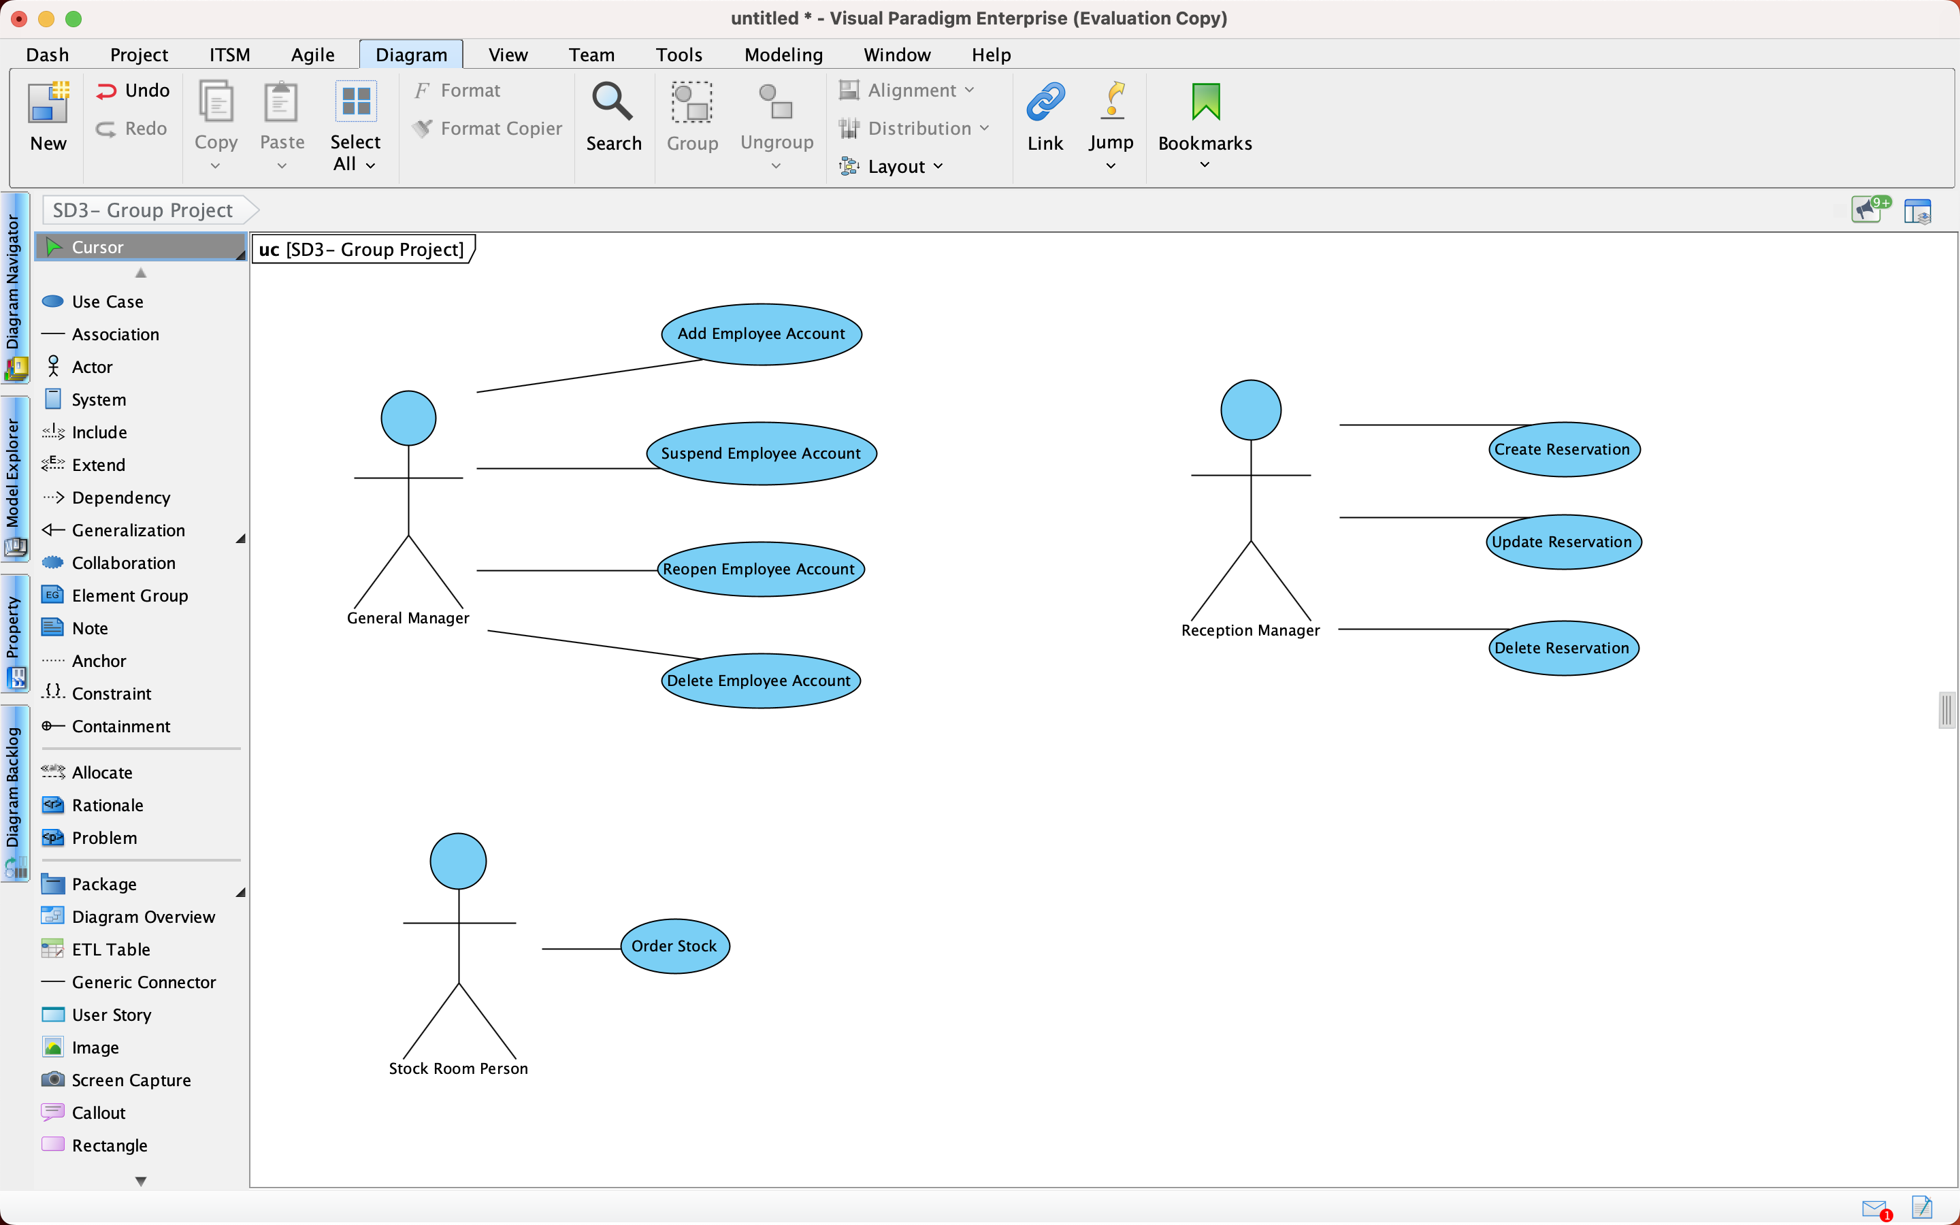

**General Manager:**

Use Case Name: Add Employee Account

Participating Actor: General Manager

Entry Conditions:

1. A new employee has been hired and they need to be added to the system
2. The add new employee function of the system has been invoked

Flow of Events:

1. The system responds by displaying the Add Employee form which has the following required fields: name, address, phone number, department
2. The general manager responds by inputing the following e.g Jane Doe, Limerick, 011 111 1111, Reception. In their respective fields.
3. The manager clicks the ok button
4. They are presented with a confirm page that displays the entered information along with a new employee ID. The manager clicks the confirm button

Exit Conditions:

1. A new employee has been added to the system

Use Case Name: Suspend Employee Account

Participating Actor: General Manager

Entry Conditions:

1. The manager would like to suspend a particular employees account
2. The employee has already been added into the system
3. The suspend employee function of the system has been invoked

Flow of Events:

1. The system responds by displaying the Suspend Employee form, which requests a name or employee ID.
2. The general manager responds by inputing the following e.g Jane Doe
3. The manager clicks the search button
4. The system responds by displaying the employees name in a table if found, with a suspend button besides it.
5. The manager clicks the suspend button and they are given a warning “Once this employee [Jane Doe] has been suspended they will lose access to the system until the account has been reopened”.
6. The manager clicks the confirm button

Exit Conditions:

1. The employee has been suspended from the system

Use Case Name: Reopen Employee Account

Participating Actor: General Manager

Entry Conditions:

1. The manager would like to reopen a suspended account
2. The employee has already been added into the system and their account is suspended
3. The reopen account function of the system has been invoked

Flow of Events:

1. The system responds by displaying the Reopen Account form, which requests a name or employee ID.
2. The general manager responds by inputing the following e.g Jane Doe
3. The manager clicks the search button
4. The system responds by displaying the employees name in a table if found, with a open account button besides it.
5. The manager clicks the open account button and they are given a warning “Once this account is reopened this user will have access to the system”.
6. The manager clicks the confirm button

Exit Conditions:

1. The suspended account has been reopened

Use Case Name: Delete Employee Account

Participating Actor: General Manager

Entry Conditions:

1. The manager would like to delete an account
2. The account in question has already been added into the system
3. The delete account function of the system has been invoked

Flow of Events:

1. The system responds by displaying the Delete Account form, which requests a name or employee ID.
2. The general manager responds by inputing the following e.g Jane Doe
3. The manager clicks the search button
4. The system responds by displaying the employees name in a table if found, with a delete account button besides it.
5. The manager clicks the delete account button and they are given a warning “Once this account is deleted it will permanently be removed from the system. This action cannot be reversed”.
6. The manager clicks the confirm button

Exit Conditions:

1. The account has been removed from the system

**Reception Manager:**

Use Case Name: Create Reservation

Participating Actor: Reception Manager

Entry Conditions:

1. A new customer wants to make a reservation in the hotel
2. The hotel still has enough capacity to accommodate the customer
3. The create reservation function of the system has been invoked

Flow of Events:

1. The system responds by displaying the Create Reservation form, which requests a name, room type, date range, card number
2. The reception manager responds by inputing the following e.g Jane Doe, Double, 25/12/2022 - 27/12/2022, [CARD NUMBER]. In their respective fields
3. The manager clicks the ok button
4. The system responds by displaying the details entered along with a reservation ID and asks the manager to confirm
5. The manager clicks the confirm button

Exit Conditions:

1. A new reservation has been added to the system

Use Case Name: Update Reservation

Participating Actor: Reception Manager

Entry Conditions:

1. A new customer wants to update an existing reservation in the hotel
2. The update reservation function of the system has been invoked

Flow of Events:

1. The system responds by displaying the Update Reservation form, which requests a reservation id
2. The reception manager responds by inputing the following e.g 111110
3. The manager clicks the ok button
4. The system responds by displaying the details entered for the reservation if found, allowing then to edit the name, room type, date range, card number fields. The manager updates the fields.
5. The manager clicks the confirm button

Exit Conditions:

1. A reservation has been updated

Use Case Name: Delete Reservation

Participating Actor: Reception Manager

Entry Conditions:

1. A new customer wants to cancel an existing reservation in the hotel
2. The cancel reservation function of the system has been invoked

Flow of Events:

1. The system responds by displaying the Delete Reservation form, which requests a reservation id
2. The reception manager responds by inputing the following e.g 111110
3. The manager clicks the ok button
4. The system responds by displaying the details entered for the reservation if found.
5. The manager clicks the delete button
6. The system responds by displaying an alert asking if they are sure they want to delete the reservation as this action cannot be undone
7. The manager clicks the confirm button

Exit Conditions:

1. A reservation has been deleted

**Full Time Stock Room Person:**

Use Case Name: Order Stock

Participating Actor: Stock Room Person

Entry Conditions:

1. The stock room person wants to place an order
2. The order stock function of the system has been invoked

Flow of Events:

1. The system responds by displaying the Order Stock form, which requests a product id or product name
2. The user responds by inputing the following e.g 111110
3. The user clicks the ok button
4. The system responds by displaying the corresponding product if found (Milk in this example). And also an input field for the quantity, the user inputs ‘100’
5. The user clicks the done
6. The system responds by displaying the order details ‘Milk x 100’. And asks the user to confirm
7. The user clicks the confirm button

Exit Conditions:

1. An order has been placed